

**Quantam Cloud Application Manual**

**Application for Electronic parts management**.

1. Open “Start.Sh” file.

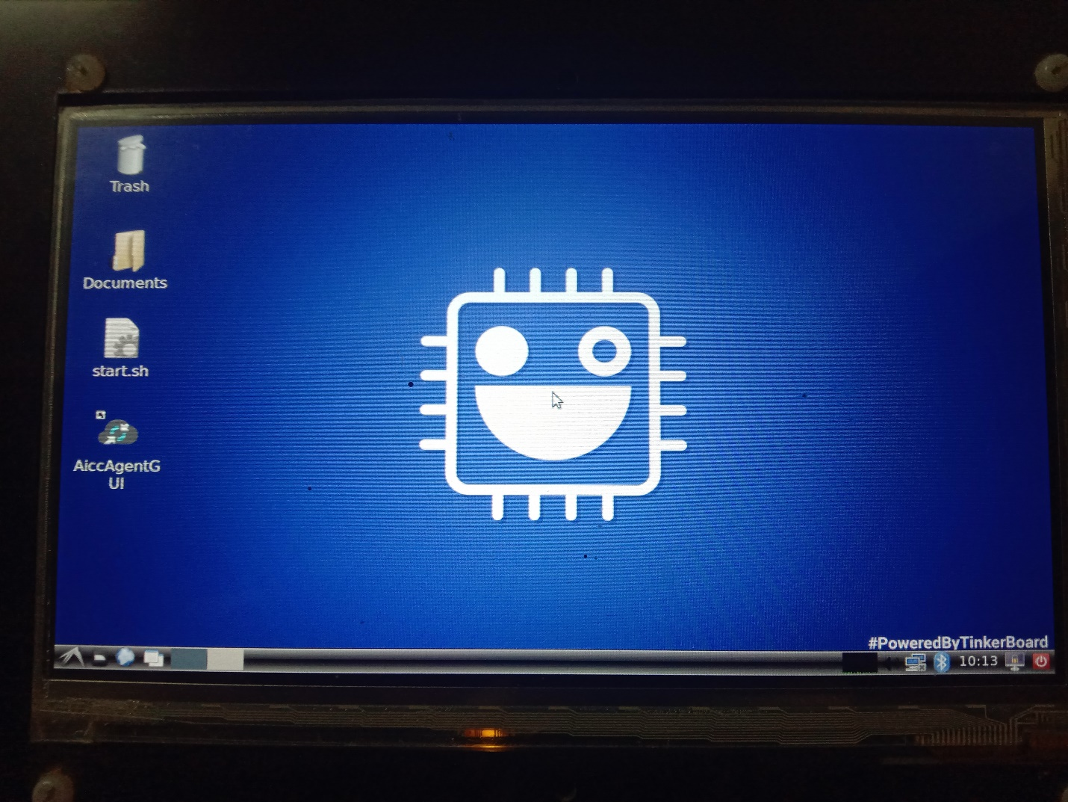

1. Click on Execute.

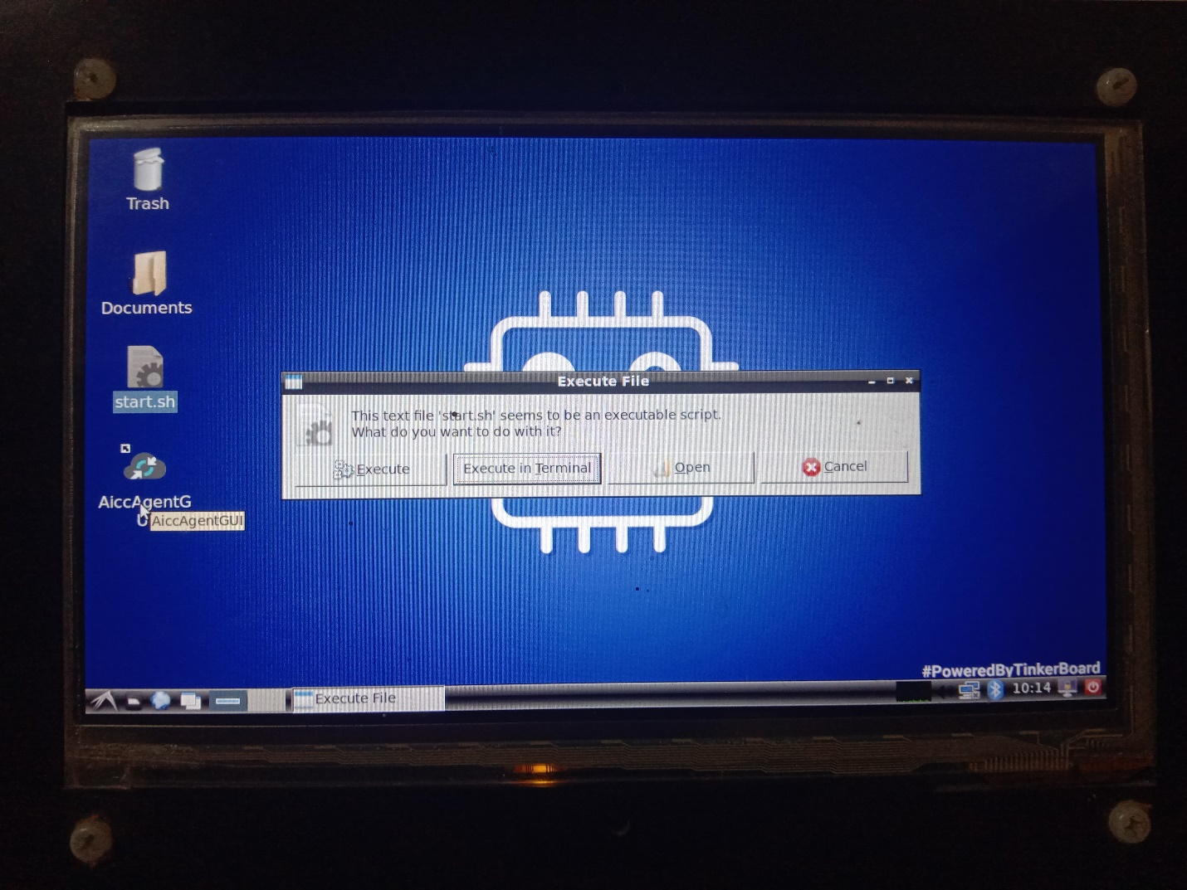

1. Login Window.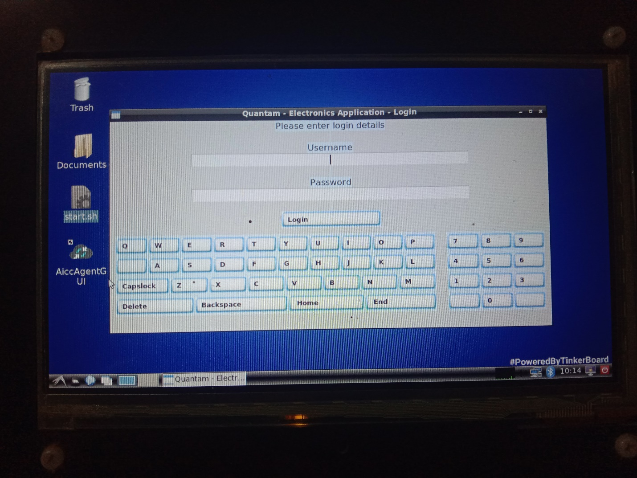
2. Login with credentials.

|  |  |
| --- | --- |
| User Name | Password |
| admin | Admin |
| user1 | user |
| user2 | user |
| user3 | user |

1. After Login Working Screen comes with menu.
   1. Double Click on any item to process.
   2. Enter Quantity to issue.
   3. Note that admin can only receive items and user can issue that quantity.
   4. Press on update.

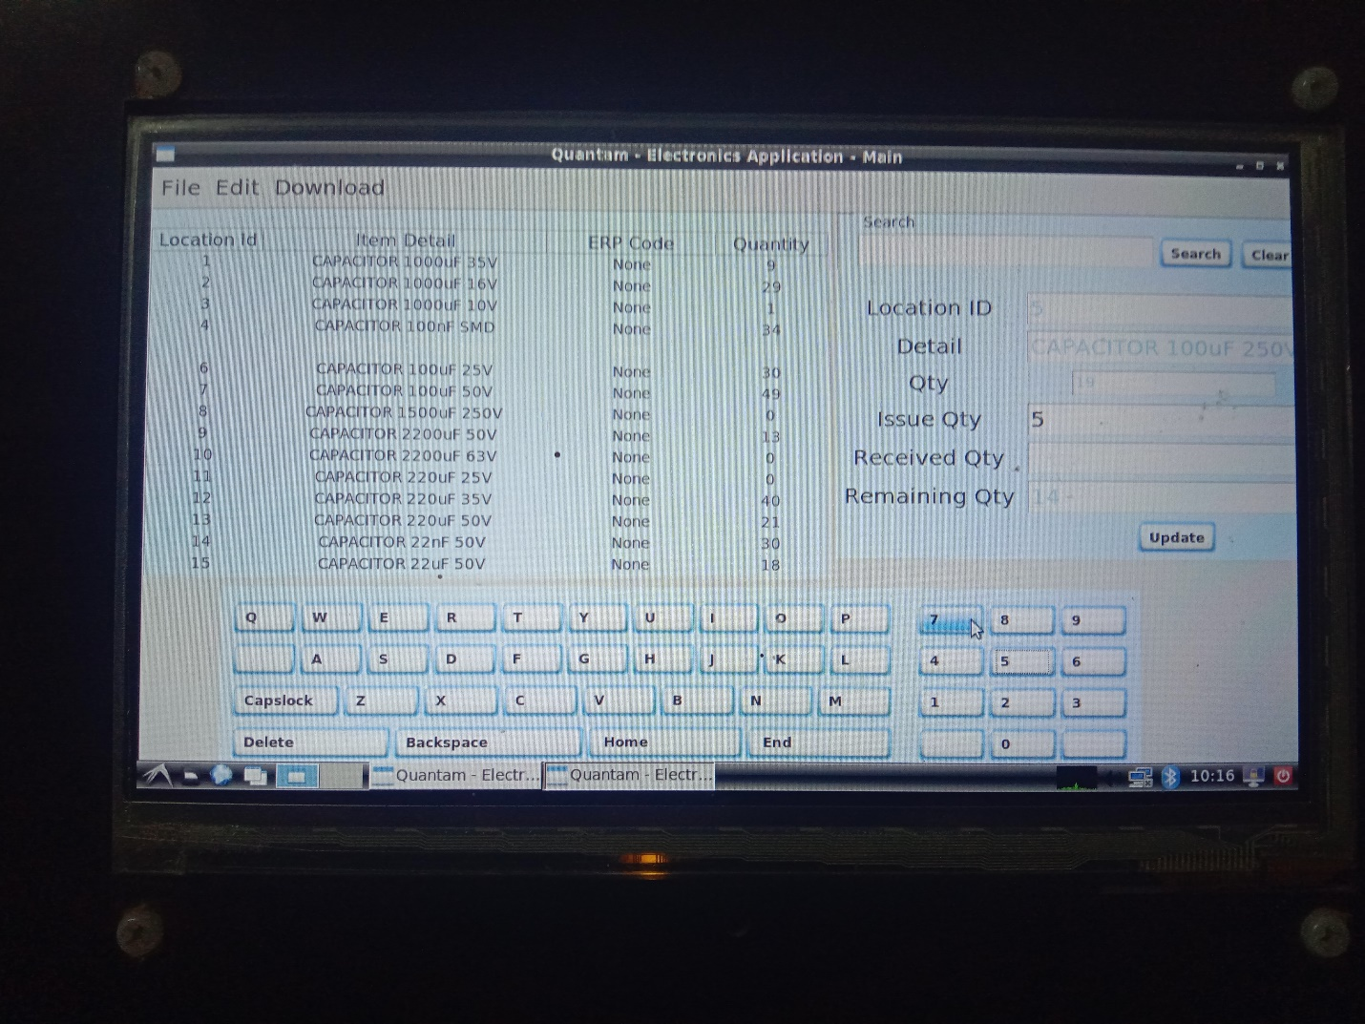

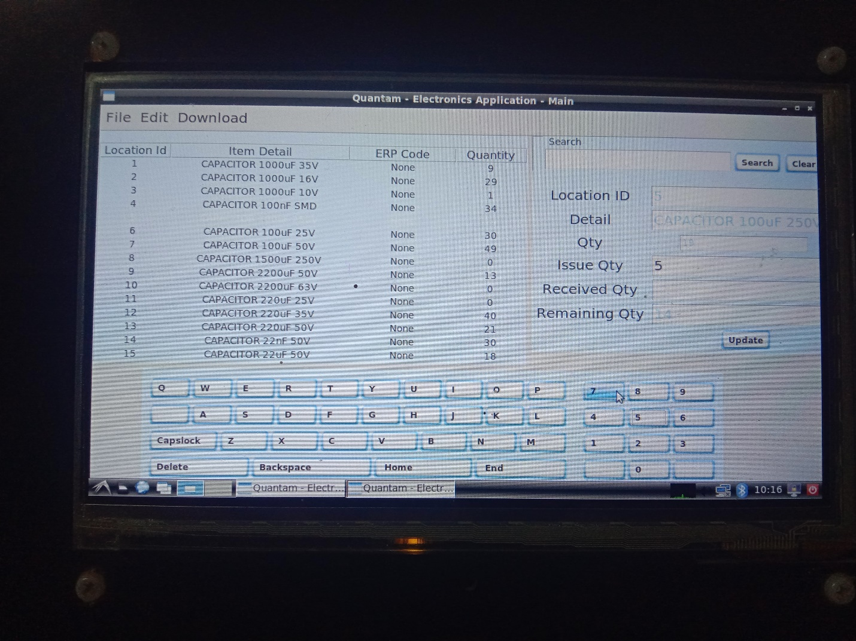

1. Download Menu.

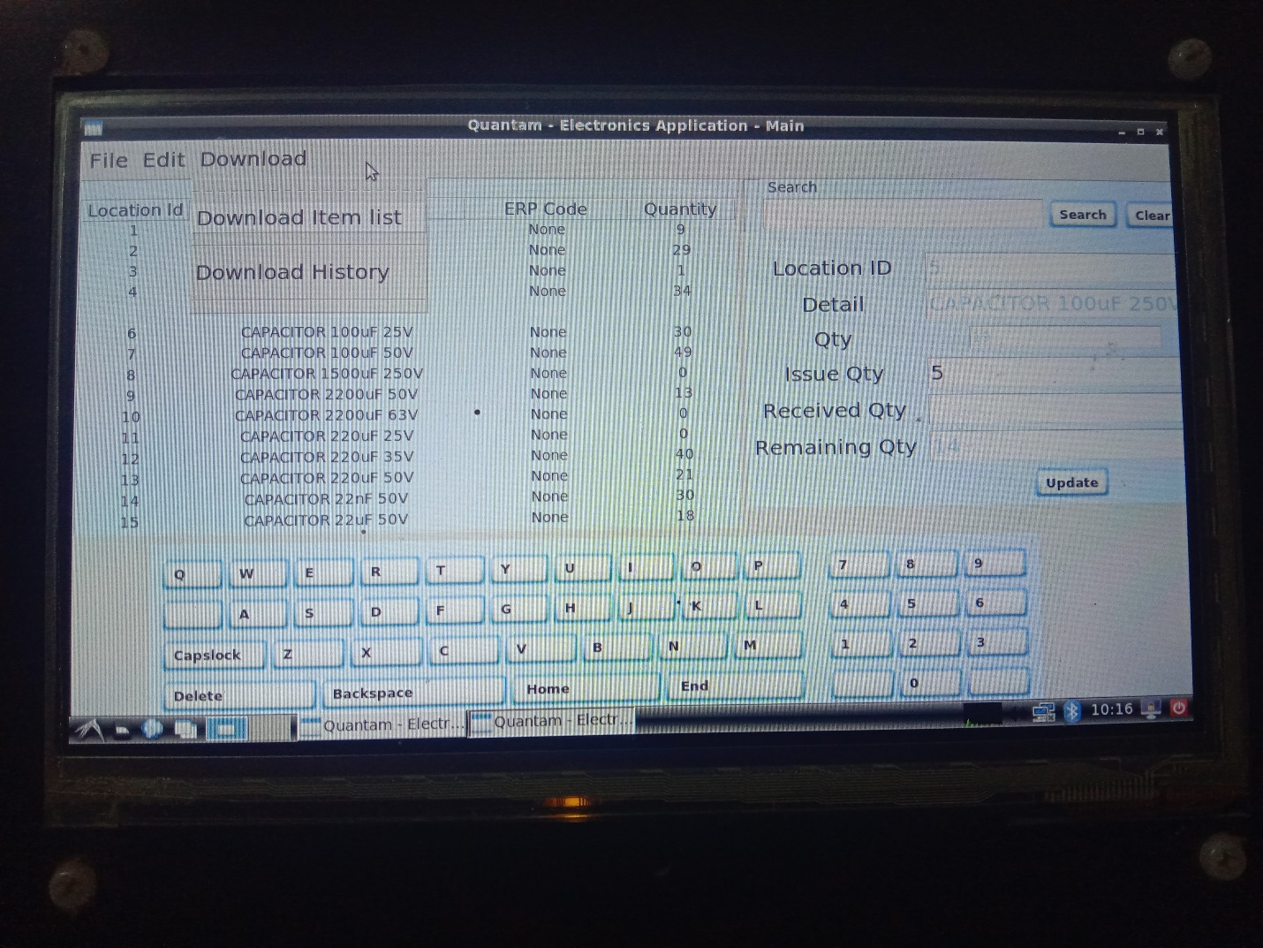

* 1. Item will be saved on below location as in image. 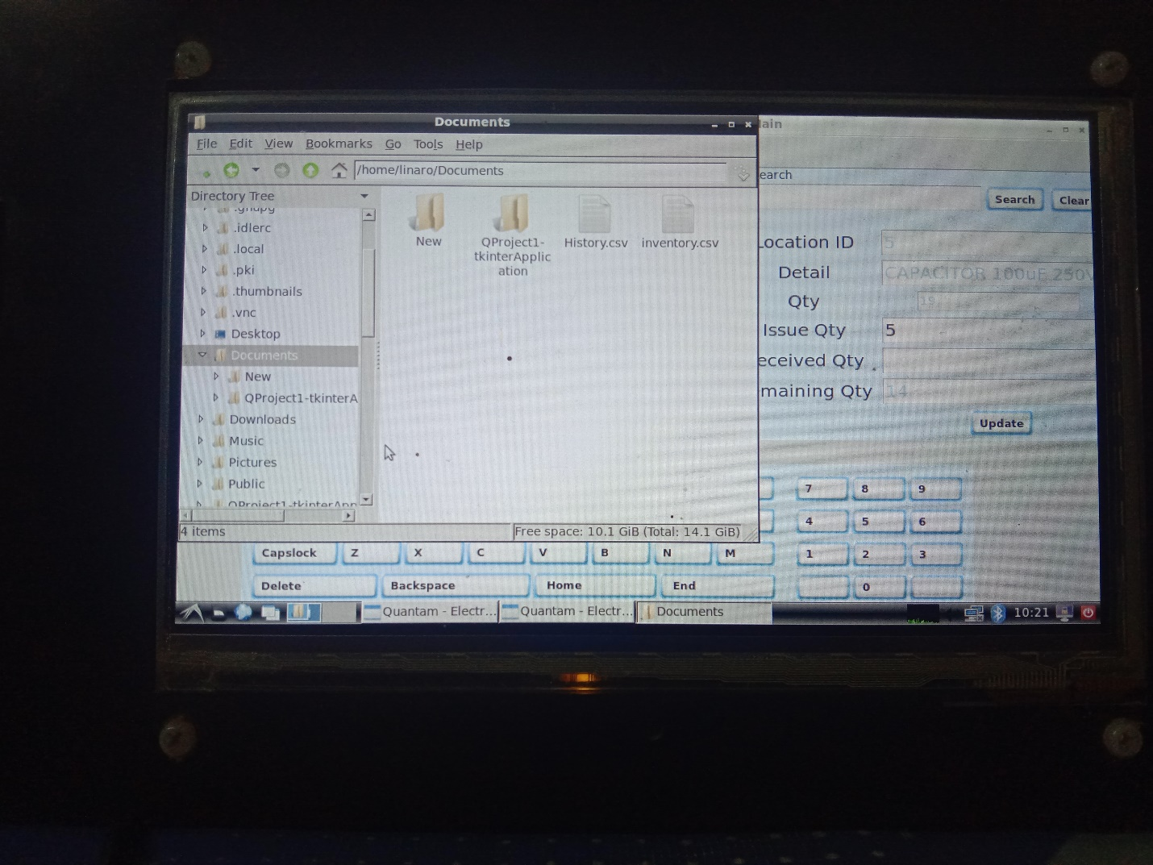
  2. Remove files before download or after download.
  3. User can copy/cut from their and paste in USB.
  4. USB path as in below. In my case ESD-ISO is USB Name. 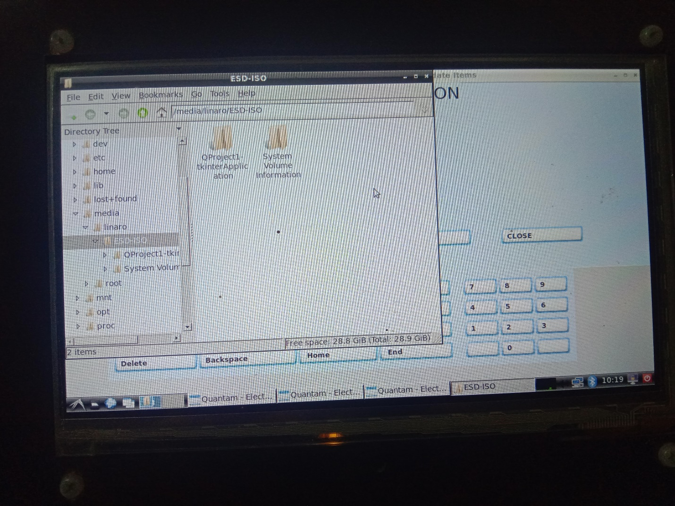

1. File Menu. 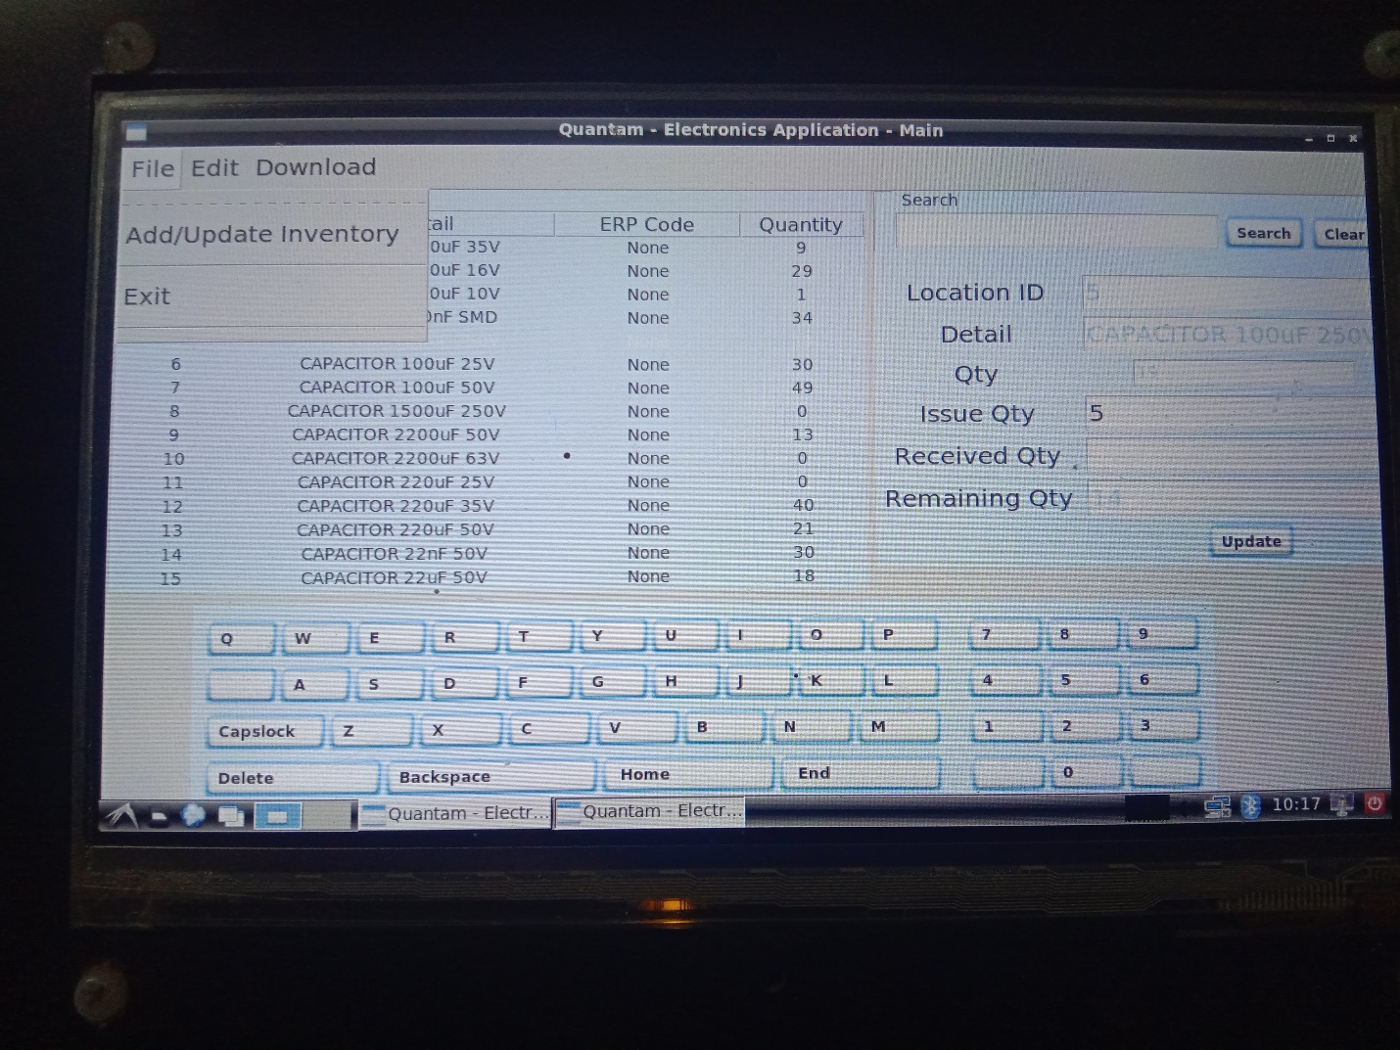
2. Select update inventory to update.
   1. Enter Rack number in first text box then go to second box. If item exists then it will show make changes and click on update.
   2. Note: default Quantity for new items is ‘0 ‘. Quantity will be manage on main form (previous form).
   3. You can add new rack numb or box in first column and press insert.

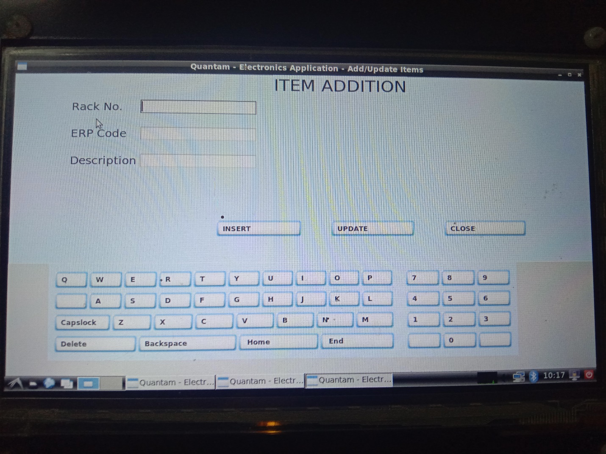

1. User can Reset own password by clicking on Edit > Reset password.

A prompt password shows. Set password and enter.

Thanks for Using Quantam Product.

For any Query feel free to contact us.